LTRR-SRP II : The Current Drought In Context: A Tree-Ring Based Evaluation Of Water Supply Variability For The Salt-Verde River Basin
PROGRESS REPORT #6
For period Nov 2006 – Feb 2007 (submitted March 9, 2007)

Katherine K. Hirschboeck & David M. Meko
Laboratory of Tree-Ring Research, The University of Arizona

WORK  PHASES | Month
WORK  PHASES | SRP Budget Year 1 |  |  |  |  |  |  |  |  |  | SRP Budget Year 2
WORK  PHASES | 2005 |  |  |  |  | 2006 |  |  |  |  |  |  |  |  |  |  |  |  | 2007
WORK  PHASES | A | S | O | N | D | J | F | M | A | M |  | J | J | A | S | O | N | D |  | J | F | M | A |  | M | J | J | A
1. Field collections
2. Processing
& new chronologies
3.Re-calibration / update of reconstructions w/ climate analyses | Ongoing climatic analysis, building on LTRR-SRP I ➔
4. Snow study
5. Integration & final report

During the project period from October 2006 through the end of February 2007, work continued on all Work Phases except (1) which is completed. Following is a report of our progress:
WORK PHASE 2: Processing of the new collections.

Progress has been made in crossdating and measuring (including earlywood and latewood widths) of the collections, but we remain behind schedule in our crossdating and chronology building and have had to extend our estimate of the completion date for this phase (to the end of May). Despite this slower pace, progress is steady. Most sites are in the measurement stage of processing or beyond and the earlywood-latewood measurements have been completed manually for 6 sites.

Efforts are in progress to speed up the partial width measurement process through the use of the Laboratory’s newly acquired LignoStation. A total of 17 samples (cores or sections) from four sites were selected for testing the ability of the LignoStation to automate the measurement of total-width and partial width. The samples cover a range of surface-types, ring clarity and false-ring appearance. We have measurements of partial width by the manual method, and will next be doing the measurements on the LignoStation. A mechanical problem with the LignoStation delayed the processing of samples in this manner. Frank Rinn, who developed the hardware and wrote the software, visited the LTRR in February to help resolve those problems and the system is now working again. If the repaired LignoStation results prove to be as accurate as our manually measured partial widths, we think that this will speed up the measurement of our remaining sites considerably.

Following is a description of the cores whose measurements are being tested on the LignoStation. It illustrates some of the challenges that exist when making automated measurements due to the condition of the samples (quality of the surface, color of the wood, etc.)
Cores Being Tested on LignoStation
(Total 17 samples)

Site #1 BRP: 07b, 10b, 19a, 20a, 20b, 22a.

07b, 10b, 20b. Question: Does surfacing core by conventional hand sanding (without a level- block) give a sufficiently plain or level surface?

19a. Earlywood-latewood (EW-LW) boundaries occur early in growth year. Surface is “bad”, meaning cells are not as clear visible. Question: How closely do the manual EW/LW-measurements with LignoStation measurements based on density?

10b, 20a, 20b. Good false-latewood bands. Question. How well does the density trace from the LignoStation identify those bands.

22a. Very good false-latewood bands. Question. How well does the density trace from the LignoStation identify those bands.

Site #2 BRF: 12c.

12c. This sample has strong color transition from the early to late part of the core. The color transition is due to a difference between heartwood and sapwood. Question: How does the LignoStation respond to the heartwood-sapwood transition? Will this type of feature be problem in earlywood-latewood identification with the LignoStation?

Site #15 WHK: 04a, 05b, 06c, 07b, 11b, 12a, 15c, 16b.

04a, 05b, 06c, 11b, 12a, 15c. These samples were re-surface with very fine-grit sandpaper. Question: What extra sample preparation for a plain or flat surface will be necessary with the LignoStation?

07b. This sample was not resurfaced, but had a reasonably good hand-sanded surface. Question: Is a reasonably good hand-sanded surface sufficient for use with the LignoStation?

16b. This sample was not resurfaced, but had a very poor-quality hand surface. Question: Does a poor-quality hand surface for our types of samples rule out use of the LignoStation?

Site # 16 WAH: 10, 51.

10. Cross-section.

51. Partially re-sanded at beginning and resinous areas. Question: How Lignostation manages different surfaces, and not well surfaced vs. re-sanding.

Table 1 shows the status of Work Phase 2 as of the end of February 2007 and Figure 1shows the site completion status in map form. Note that two prospective re-collection sites (#4 and #9) are no longer being considered for the study because collections were not possible (i.e., the site was inaccessible at the time of the collection trip or the trees were no longer there). Upon re-evaluation of all the samples obtained thus far at the collected sites, we have determined that additional field collections will not be needed, and therefore we do not anticipate the processing of any new samples. We are fairly confident that this most critical phase of the project will finally be completed by the end of May.
Table 1. Status of Collections, Lab Work & Chronology Development as of February 2007
----------------------------------------------------------------------------------
Map# Site Name Species¹ Lat Long El(ft) T² S³ E-L⁴ Date⁵ N_{T}⁶
----------------------------------------------------------------------------------
1 Black River Pine PIPO 33.81 -109.32 7921 B M ✓ 2005-11-17 25
2 Black River Fir PSME 33.81 -109.32 6754 B C ✓ 2005-09-23 20
3 Black Mountain Lookout PSME 33.38 -108.22 8692 B M 2005-10-13 15
4 Dry Creek PIED 34.89 -111.82 4526 E* N/A 2005-10-21 0
5 East Clear Creek PIPO 34.55 -111.16 6706 B M ✓ 2005-11-11 19
6 Gus Pearson PIPO 35.27 -111.74 7423 B C ✓ 2005-10-27 30
7 Jacks Canyon PIED 34.75 -111.11 6303 B M 2005-11-10 17
8 Mogollon Rim West Fir PSME 34.44 -111.29 7511 E D 2005-11-03 5
9 Oak Spring Canyon PIPO 33.92 -111.40 6199 E N/A 2005-10-19 0
10 Robinson Mountain PIPO 35.38 -111.56 7313 B M 2005-10-27 30
11 Red Butte PIED 35.83 -112.08 6332 B (D) 2005-10-28 16
12 Rocky Gulch PIPO 34.73 -111.52 6453 B M 005-11-10 22
13 Slate Mountain PIPO 35.52 -111.83 7027 B (M) 2005-10-28 31
14 Sitgreaves Gravel Pit PIPO 34.25 -109.94 6740 B (M) 2005-09-24 24
15 Wahl Knoll PSME 34.00 -109.39 9625 B C ✓ 2005-11-19 18
16 Wolf Head Draw Fir PSME 33.40 -108.22 6593 E M ✓ 2005-10-13 8
17 Oak Creek Canyon PSME 35.03 -111.74 5904 E* P 2005-10-21 4
18 Wolf Creek Campground PIPO 34.45 -112.45 5871 E* P 2005-10-21 4
-----------------------------------------------------------------------------
¹ Species: PSME = Pseudotsuga menziesii; PIPO = Pinus ponderosa PIED = Pinus edulis
² T: type of collection (B=full collection, sufficient for building chronology; E=exploratory, possibly to be expanded; E*=preliminary, with no plans for follow-up collection for building chronology)

³ S: status P=prepared +> D=dated => M=measured => C=chronology built
“( )” indicates the operation is still in progress.
NOTE: 4 Dry Creek . . .N/A means the site is not being used (collections not possible, trees no longer there, etc.)

⁴ E-L a check ✓ means Earlywood/Latewood measurements have been completed
⁵ Date Collected

⁶ N_{T}: number of trees sampled
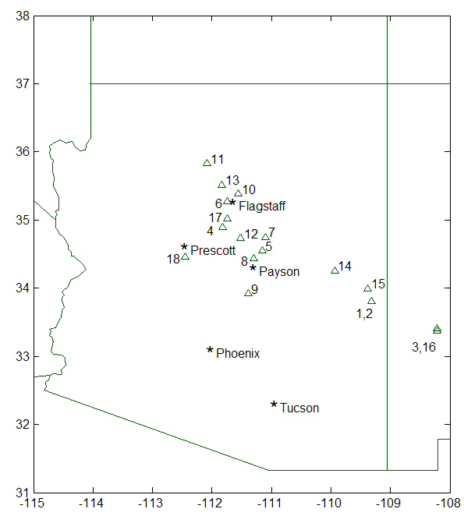
Figure 1. Locations & status of tree-ring sites collected or scouted as of February 2007.

= dated through 2005
= measured or being measured
= chronology has been built
w/ EW/LW measurements

= eliminated sites

WORK PHASE 3: Re-calibration / update of reconstructions w/ climate analyses

The re-calibration and updating of the Salt-Verde tree-ring streamflow reconstruction will begin when all the total-width and partial-width measurements are complete. In the meantime, the statistical procedure for producing tree-ring based reconstructions using partial width measurements is being refined. We are also continuing to use the PRISM historical climate dataset to check the strength of the local precipitation signal in the tree-ring chronologies as they are developed. Monthly historical PRISM climate data for precipitation, maximum temperature, minimum temperature, and dewpoint, have been downloaded for all eighteen site locations shown in Table 1.

Analysis of the circulation patterns linked to anomalous high and low flow episodes in the Salt/Verde Basin continues. Using the gauged record we are examining correlation fields and composites of the 700 mb pressure height fields associated with high and low streamflow in the Salt-Verde watersheds. For example, the mean dominant circulation patterns that affect the flow of the Verde below Tangle Creek during a representative fall and winter month are shown below. These are based on the gridpoint correlations between 700 mb heights and mean monthly streamflow at a single gauge over a 30-year period of record. By comparing these typical patterns with those found in the same months and seasons during years of extreme drought and heavy flows, we are attempting to identify the following: (a) unique circulation features (cutoff lows, blocking highs, etc.) that are associated with extreme high or low streamflow episodes, (b) an unusual persistence of common circulation patterns that may have culminated in an extreme streamflow episode, (c) any anomalous or unseasonable occurrences of a specific circulation pattern that appears to be associated with extreme streamflow conditions, or (d) a shift in the typical latitudinal or longitudinal location of a circulation feature (e.g., ridge or trough location) that appears to be associated with an extreme steamflow episode. Once identified, these features will then be analyzed in terms of their frequency of occurrence and possible linkage with various teleconnection and atmospheric / oceanic circulation indices (PNA, AO, SOI, PDO, AMO, etc.). Based on this, we will investigate the possibility of developing a robust, regionally tailored circulation index that effectively tracks streamflow extremes in the Salt-Verde watersheds.

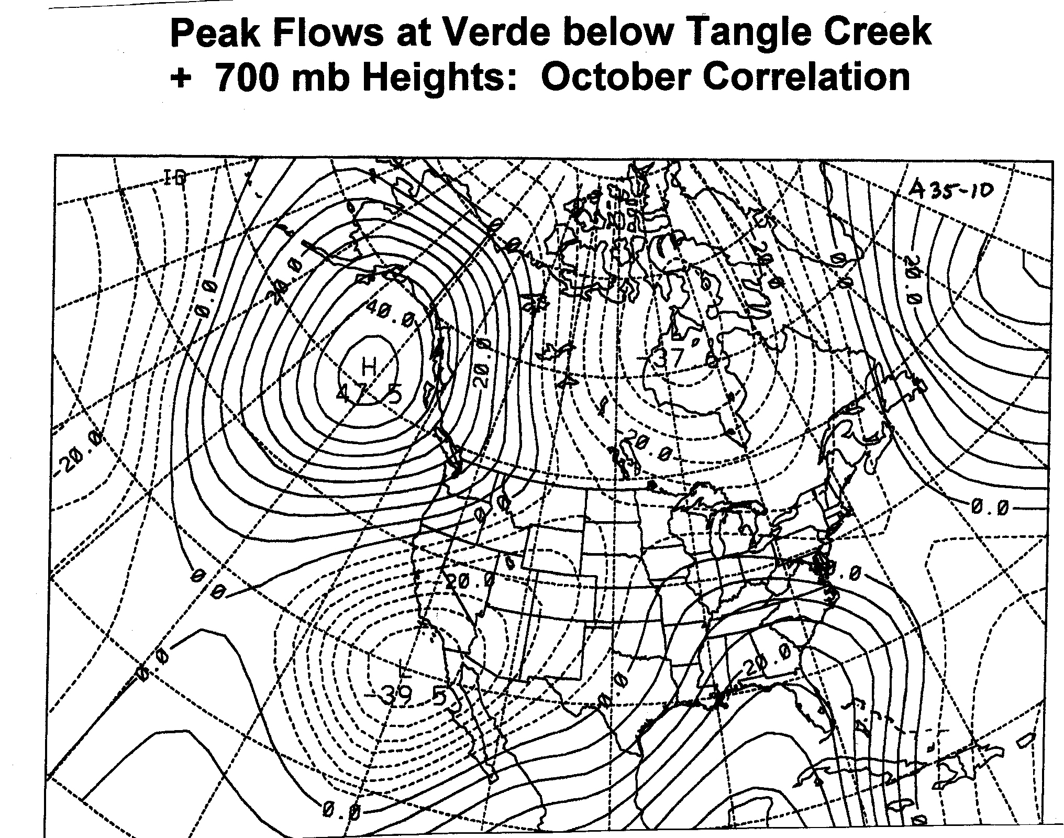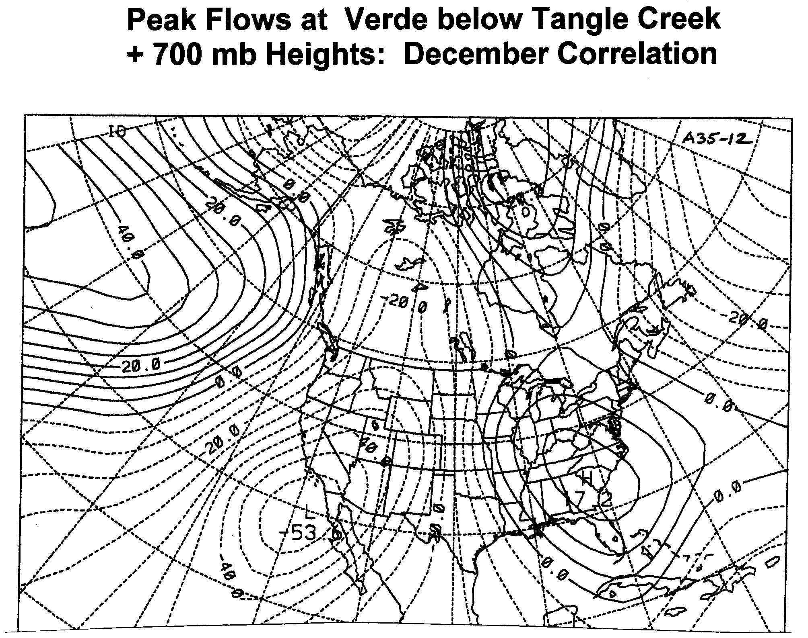
(note the similarity of the October correlation field with the PNA teleconnection pattern)

WORK PHASE 4: Analysis of the relationship between tree-ring data and snow variables through remotely sensed observations.

Ela Czyzowska’s project is progressing. She has good preliminary results from her artificial neural network estimates of fractional snow cover based on a fusion methodology between remotely sensed data at the highest available temporal resolution (daily images using MODIS imagery) and the highest available spatial resolution ( 1 m using IKONOS imagery). She is about to submit a third-year renewal proposal to NASA for the continuation of her algorithm development (in the San Juan Mountains) and has begun some preliminary analysis of tree-ring data from the region for incorporation into her study. After her snow cover estimation algorithm has been tested and validated, she will transfer it to alpine-forested regions in the Salt-Verde watershed as a case study application.

WORK PHASE 5: Integration & final report.

In anticipation of the final report, we are beginning to organize our data files and write up parts of our methods sections for insertion into the report at project completion time.

SUMMARY

We are still somewhat behind schedule with respect to our original timeline because of the extra time needed to complete the measurement part of Phase 2. Although moving at a slower pace, progress is steady and we hope we will be able to move faster if the LignoStation automated measuring of earlywood and latewood proves to be as accurate as that being done manually. (This is being evaluated right now). We expect to be in the re-calibration stage of Work Phase 3 and beginning the streamflow reconstructions by the end of May and are still aiming for project completion by the end of the summer.

