LTRR-SRP II : The Current Drought In Context: A Tree-Ring Based Evaluation Of Water Supply Variability For The Salt-Verde River Basin
PROGRESS REPORT #5
For period Aug - Oct 2006 (submitted Nov 22, 2006)

Katherine K. Hirschboeck & David M. Meko
Laboratory of Tree-Ring Research, The University of Arizona

WORK  PHASES | Month
WORK  PHASES | SRP Budget Year 1 |  |  |  |  |  |  |  |  |  | SRP Budget Year 2
WORK  PHASES | 2005 |  |  |  |  | 2006 |  |  |  |  |  |  |  |  |  |  |  |  | 2007
WORK  PHASES | A | S | O | N | D | J | F | M | A | M |  | J | J | A | S | O | N | D |  | J | F | M | A |  | M | J | J | A
1. Field collections
2. Processing & new chronologies
3.Re-calibration / update of reconstructions w/ climate analyses | Ongoing climatic analysis, building on LTRR-SRP I ➔
4. Snow study
5. Integration & final report

During the project period from August 1 through the end of October 2006, work continued on all Work Phases except (1) & (5). Following are some of the highlights of our progress:
WORK PHASE 2: Processing of the new collections.

Since Report #4, significant progress has been made in crossdating and measuring (including earlywood and latewood widths) of the collections (see Table 1 and Figure 1). Note that each site has to progress through the sequential steps of processing (P), crossdating (D), measurement (M) and chronology development (C). We now have two sites (Wahl Knoll and Black River Fir) complete through chronology development phase. Indices of partial width (earlywood, latewood) as well as total width have been developed for these two sites. At this point in time, we are slightly behind in our crossdating and chronology building schedule because of the additional time needed for accurate earlywood and latewood measurements. (Additional sample sanding is needed to produce a better surface for viewing the earlywood-latewood transition.) Despite this slower pace, measurements have been completed or are in progress for five additional sites. Three sites have been dated but not yet measured, and several sites have not yet been dated.

At least one additional field collection is planned before the end of the year, probably for additional collection at Wolf Head Draw (Site #16).

Table 1. Status of Collections, Lab Work & Chronology Development

-----------------------------------------------------------------------------
Map# Site Name Species¹ Lat Long El(ft) T² S³ Date⁴ N_{T}⁵
-----------------------------------------------------------------------------

1 Black River Pine PIPO 33.81 -109.32 7921 B (M) 2005-11-17 25
2 Black River Fir PSME 33.81 -109.32 6754 B C* 2005-09-23 20
3 Black Mountain Lookout PSME 33.38 -108.22 8692 B D 2005-10-13 15
4 Dry Creek PIED 34.89 -111.82 4526 E* R 2005-10-21 0
5 East Clear Creek PIPO 34.55 -111.16 6706 B M 2005-11-11 19
6 Gus Pearson PIPO 35.27 -111.74 7423 B D 2005-10-27 30
7 Jacks Canyon PIED 34.75 -111.11 6303 B M 2005-11-10 17
8 Mogollon Rim West Fir PSME 34.44 -111.29 7511 E P 2005-11-03 5
9 Oak Spring Canyon PIPO 33.92 -111.40 6199 E N/A 2005-10-19 0
10 Robinson Mountain PIPO 35.38 -111.56 7313 B (M) 2005-10-27 30
11 Red Butte PIED 35.83 -112.08 6332 B P 2005-10-28 16
12 Rocky Gulch PIPO 34.73 -111.52 6453 B M 2005-11-10 22
13 Slate Mountain PIPO 35.52 -111.83 7027 B P 2005-10-28 31
14 Sitgreaves Gravel Pit PIPO 34.25 -109.94 6740 B D 2005-09-24 24
15 Wahl Knoll PSME 34.00 -109.39 9625 B C* 2005-11-19 18
16 Wolf Head Draw Fir PSME 33.40 -108.22 6593 E (M) 2005-10-13 8
17 Oak Creek Canyon PSME 35.03 -111.74 5904 E* P 2005-10-21 4
18 Wolf Creek Campground PIPO 34.45 -112.45 5871 E* P 2005-10-21 4
-----------------------------------------------------------------------------
¹Species: PSME = Pseudotsuga menziesii; PIPO = Pinus ponderosa PIED = Pinus edulis
²T: type of collection (B=full collection, sufficient for building chronology; E=exploratory, possibly to be expanded; E*=preliminary, with no plans for follow-up collection for building chronology)
³S: status (P=prepared (mounted and sanded), D=dated, M=measured, C=chronology built “()” indicated operation in progress. A code of “ C*” means that earlywood-latewood chronologies have been developed as well as the total-width chronology ⁴N_{T}: number of trees sampled
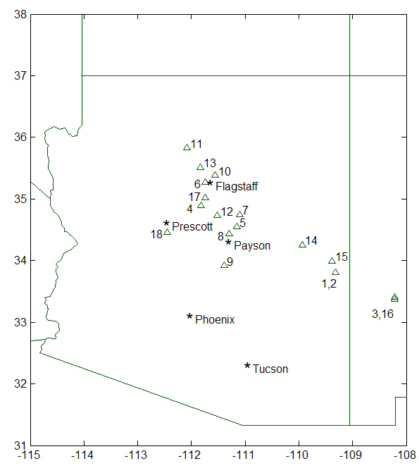

= dated through 2005
= measured or being measured
= chronology has been built
w/ EW/LW measurements

Figure 1. Locations & status of tree-ring sites collected or scouted as of November 1, 2006.

To facilitate and speed up the measuring process, we are experimenting with a new automated technique for earlywood-latewood identification and measurement using a new instrument system recently acquired by the Laboratory of Tree-Ring Research. The LignoStation, developed in German by Frank Rinn, is an all-in-one tree-ring processing instrument that uses microwaves to measure variations in wood density across the ring. The advantage to our project would primarily be an automated method of identifying the boundary between earlywood and latewood, thus removing the need to make a very subjective decision that will vary greatly from one technician to another. With the LignoStation, we hope to be able to set a threshold of wood density that makes the determination of the earlywood-latewood boundary exactly repeatable for the same wood sample. Angelika Clemens is doing some tests with SRP wood samples collected in Fall 2005 to see whether this will be a useful tool for the project. The LignoStation is described at: http://www.rinntech.com/Products/Lignostation.htm

The LTRR purchased this instrument for general use in the Laboratory in August and our SRP project team is one of the first research groups to experiment with applications.

WORK PHASE 3: Re-calibration / update of reconstructions w/ climate analyses

We have begun using the PRISM historical climate dataset (Gibson et al. 2002) to check the strength of the “local” precipitation signal in the tree-ring chronologies as they are developed. The PRISM data are available online at: http://www.ocs.oregonstate.edu/prism/. The dataset is monthly, and consists of precipitation, maximum temperature, minimum temperature, and dewpoint. The historical dataset extends from 1895 to present at 4 km resolution. It is based on interpolation from climatological station networks and COOP data, and is useful for our project because we can readily download time series at the specified longitude-latitude coordinates of the tree-ring sites. For each tree-ring site we are checking scatterplots of water-year-total, cool season (Oct-Apr), pre-summer (May-June), and summer (July-Sept) precipitation on indices of total-width, earlywood width, etc. A sample is shown in Figure 2 for the Black River Fir site and water-year total precipitation. The plots show a strong precipitation signal in both total-width and earlywood-width index. Plots (not shown) for the summer season at this site show a statistically significant but weak (r = 0.31) precipitation signal in the latewood index. Because summer precipitation is spotty, the correlation for an individual tree-ring site probably greatly underestimates the signal strength that might be achievable from multiple sites.

We recently held an informal workshop to evaluate the PRISM data for our project. Participants included the members of our research team, graduate student James Tamerius (UA Geography) and Bob Maddox. Several questions were raised about the local-scale accuracy of the PRISM dataset and the degree to which topography controls the spatial patterns of precipitation, but we noted that the dataset appears to capture interannual variability at the regional scale and is probably suitable for the seasonal precipitation signal purpose described above.

Analysis of the circulation patterns linked to anomalous high and low flow episodes in the Salt/Verde Basin continues. Our next progress report will include results of some of this work.

WORK PHASE 4: Analysis of the relationship between tree-ring data and snow variables through remotely sensed observations.

Ela Czyzowska has prepared a poster summary of some of her progress on the snow project to date. It is included as a PDF with this report.

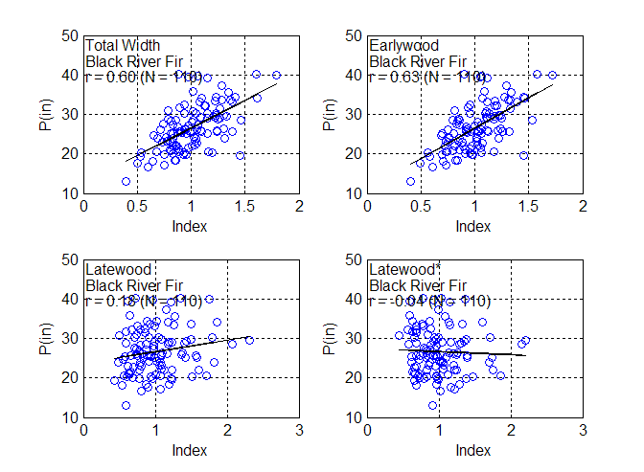
Figure 2. Scatterplots of water-year-total PRISM precipitation on tree-ring indices for Black River Fir site. Site is in the headwaters of the North Fork of the Black River, a tributary of the Salt River. Correlations are based on water years 1896-2005 (100 years). The four frames represent different components of the annual ring. “Latewood*” is an the latewood index adjusted for removal of linear dependence on earlywood index of the same year, following Meko and Baisan (2001).

SUMMARY

We are currently slightly behind schedule with respect to our estimated timeline because the partial-width measurements of earlywood and latewood are taking longer than expected. We do, however, have two complete site chronologies with total and partial ring-width measurements, and more to come. Follow-up field work is planned for late 2006 to collect more cores from one or more field sites. Soon we will be ready to proceed with the re-calibration and updates of the streamflow reconstructions, which is the next major phase of the project.

References

Gibson W., Daly C., Kittel T., Nychka D., Johns C., Rosenbloom N., McNab A. and Taylor G. (2002) Development of a 103-year high-resolution climate data set for the conterminous United States, pp. 181-183. Proc., 13th AMS Conf. on Applied Climatology, Amer. Meteorological Soc., Portland, OR, May 13-16.
Meko D. M. and Baisan C. H. (2001) Pilot study of latewood-width of confers as an indicator of variability of summer rainfall in the north American Monsoon region. International J. of Climatology 21, 697-708.

