LTRR-SRP II : The Current Drought In Context: A Tree-Ring Based Evaluation Of Water Supply Variability For The Salt-Verde River Basin
PROGRESS REPORT #2
January 31, 2006

Katherine K. Hirschboeck & David M. Meko
Laboratory of Tree-Ring Research, The University of Arizona

WORK  PHASES | Month
WORK  PHASES | SRP Budget Year 1 |  |  |  |  |  |  |  |  |  | SRP Budget Year 2
WORK  PHASES | 2005 |  |  |  |  | 2006 |  |  |  |  |  |  |  |  |  |  |  |  | 2007
WORK  PHASES | A | S | O | N | D | J | F | M | A | M |  | J | J | A | S | O | N | D |  | J | F | M | A |  | M | J | J | A
1. Field collections
2. Processing & new chronologies
3.Re-calibration / update of reconstructions w/ climate analyses |  | Ongoing climatic analysis, building on LTRR-SRP I ➔
4. Snow study
5. Integration & final report

As of the end of January 2006, additional progress has been made on Work Phases, (1), (2) and (4) in addition to the continuation of ongoing climatic analysis work that builds on LTRR-SRP I. (part of Work Phase 3).

WORK PHASE 1: Collection and recollection of tree ring cores from selected sites in order to develop new chronologies and update existing chronologies.

Since our last report, Dave Meko completed one more collecting trip; hence a total of six field trips have been taken so far. Two new sites have been added to our listing in Table 1, for a total of 18 sites. As noted in Progress Report #1, not all of these will eventually be operationally usable. (In particular, the sites labeled as "Exploratory" (E) in the "Type of Collection" column (T) of Table 1 are unlikely to result in chronologies for this project but may be useful in future work.)

WORK PHASE 2: Processing of the new collections.

The "Status" (S) column in Table 1 indicates the status of each collection in the sample preparation and processing sequence. Several of the new collections are mounted and sanded. Two site collections have been dated (D) to extend the chronology up through 2005: Black River Fir and Sitgreaves Gravel Pit. The amount of time needed to process and date the tree-ring cores at a site varies. Sites in which the trees contain a lot of false ring bands (which are potentially linked to a summer monsoon precipitation signal) take more time than other sites. As an illustration, the cores from the 24 trees sampled at the Sitgreaves Gravel Pit site took our dating expert, Christine Hallman, about one week to mount and sand, but about 4 weeks to crossdate due to the frequency of false ring bands. In contrast, the cores from the 20 trees at the Black River Fir site were crossdated in 2 weeks. These newly dated sites confirm the severity of the recent drought. Figure 2 depicts a dated core from the only tree (of 24 sampled) at the Sitgreaves Gavel Pit site that contained rings for both 2000 and 2002. One or both of these years were missing on all other trees sampled at that site! Figure 2 may be an ominous indicator of what our further results may reveal. As of January 31, we are on schedule with this work phase.

Table 1. Field collections of tree-ring sites
(Sites with yellow highlighting are new. Sites bolded and shaded have been dated through 2005)

-----------------------------------------------------------------------------
Map# Site Name Species¹ Lat Long Elev(ft) T ² S ³ Date ⁴ N_{T} ⁵
-----------------------------------------------------------------------------

1 Black River Pine PIPO 33.81 -109.32 7921 B S 2005-11-17 25
2 Black River Fir PSME 33.81 -109.32 6754 B D 2005-09-23 20
3 Black Mountain Lookout PSME 33.38 -108.22 8692 B P 2005-10-13 16
4 Dry Creek PIED 34.89 -111.82 4526 B R 2005-10-21 0
5 East Clear Creek PIPO 34.55 -111.16 6706 B S 2005-11-11 19
6 Gus Pearson PIPO 35.27 -111.74 7423 B S 2005-10-27 30
7 Jacks Canyon PIED 34.75 -111.11 6303 B S 2005-11-10 17
8 Mogollon Rim West Fir PSME 34.44 -111.29 7511 B R 2005-11-03 0
9 Oak Spring Canyon PIPO 33.92 -111.40 6199 B R 2005-10-19 0
10 Robinson Mountain PIPO 35.38 -111.56 7313 B S 2005-10-27 30
11 Red Butte PIED 35.83 -112.08 6332 B S 2005-10-28 16
12 Rocky Gulch PIPO 34.73 -111.52 6453 B S 2005-11-10 22
13 Slate Mountain PIPO 35.52 -111.83 7027 B S 2005-10-28 31
14 Sitgreaves Gravel Pit PIPO 34.25 -109.94 6740 B D 2005-09-24 24
15 Wahl Knoll PSME 34.00 -109.39 9625 B S 2005-11-19 18
16 Wolf Head Draw Fir PSME 33.40 -108.22 6593 B R 2005-10-13 7
17 Oak Creek Canyon PSME 35.03 -111.74 5904 E R 2005-10-21 4
18 Wolf Creek Campground PIPO 34.45 -112.45 5871 E R 2005-10-21 4

-----------------------------------------------------------------------------
¹Species: PSME = Pseudotsuga menziesii; PIPO = Pinus ponderosa
PIED = Pinus edulis
²T: type of collection (B=chronology building, E=exploratory)
³S: status (R=reconnaisance or spot-sampled, S=full samples collected,
P=prepared (mounted and sanded), D=dated, M=measured, C=chronology built
⁴N_{T}: number of trees sampled
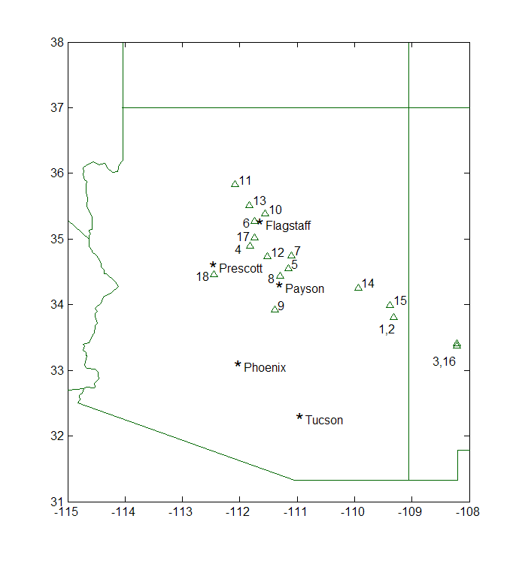
= newly collected

Figure 1. Locations of tree-ring sites collected or scouted as of January 31, 2006

Figure 2. Core from the only tree (of 24 sampled) at the Sitgreaves Gravel Pit site
that contained rings for both 2000 and 2002
\\ = false ring bands
[NOTE: The latewood ring boundary for 2002 is very faint and barely visible]

WORK PHASE 3: Analysis of droughts and high flow extreme years in the context of present and past climatic variability.

The analysis of correlation fields and composite maps of key periods of extreme episodes of high and low flow has continued. Graduate student Ashley Coles has been focusing on the apparent shift in the position of seasonal anomaly centers in the composite 500 mb circulation maps of LL and HH years noted in our earlier study (LTRR-SRP-I). We had observed that (in LL years especially) a seasonal pressure height anomaly was situated over the western U.S. during the early half of the cool season (Oct-Dec), but had shifted to the eastern North Pacific Ocean during the late half of the cool season (Jan-Mar). To investigate this further, Ashley examined the early- and late- cool season anomaly maps of individual years to see how representative the composite patterns were of individual year variability. It was noted that most of the maps matched the multi-year composites fairly well, except for the late-cool season (Jan-Mar) of both the HH and LL years. This is seen in Figure 3, which shows the five individual HH years used in the HH composite for January through March. The figure reveals how individual year patterns can cancel each other out in a multi-year composite: two years have a very strong upper level high pressure anomaly over the eastern North Pacific Ocean, two have a strong upper level low pressure anomaly, and the fifth year is the one that most closely resembles the composite. In contrast, each of the early cool season individual year patterns (Oct-Dec) were extremely close to the composite. Our preliminary conclusion is that there is a fairly consistent synoptic pattern for the early half of the cool season prior to HH and LL years, but a more variable pattern in the second half of the cool season during these extreme years. We are now examining the synoptic pattern of some of the more extreme recent years (including Oct -Dec of 2005) to see how they compare with these results.

Figure 3 Comparison of individual year 500 mb circulation anomaly patterns with the multi-year composite anomaly pattern for January - March during HH years in the observed record

WORK PHASE 4: Analysis of the relationship between tree-ring data and snow variables through remotely sensed observations.

Processing and co-registration of IKONOS, Landsat, and MODIS archived images has taken place for the study area being used to develop the snow cover algorithms (located in the San Juan Mountains). Ela Czyzowska has initiated work on the neural-network-based fractional snow cover estimation process (described in detail in Appendix A). In addition, once the estimation algorithms are developed, Ela has arranged for the results to be validated based on ground measurements collected in aninstrumented watershed operated by the Center for Snow and Avalanche Studies (see Figs A-2 and A-3 in Appendix A). Work on this aspect of the project is proceeding on schedule.

SUMMARY

Thus far our progress in each work phase is on schedule with our estimated project time line. We can also report that our budget and project account # situation has been straightened out. Most importantly, the initial results from our first updated collections reveal dramatic evidence of the severity of some of the most recent years of drought in the Salt-Verde Basin!

[NOTE: We have not yet had a meeting or workshop about the new project with the Hydrology Group at SRP. Please advise us on whether such a meeting should take place, and if so, what would be the best time for this.]

APPENDIX A: DETAILED UPDATE FOR WORK PHASE 4
by Ela Czyzowska 1-31-05

Artificial Neural Network (ANN) training on IKONOS and Landsat TM5 images with fresh snow cover (images from 18th December 2001).

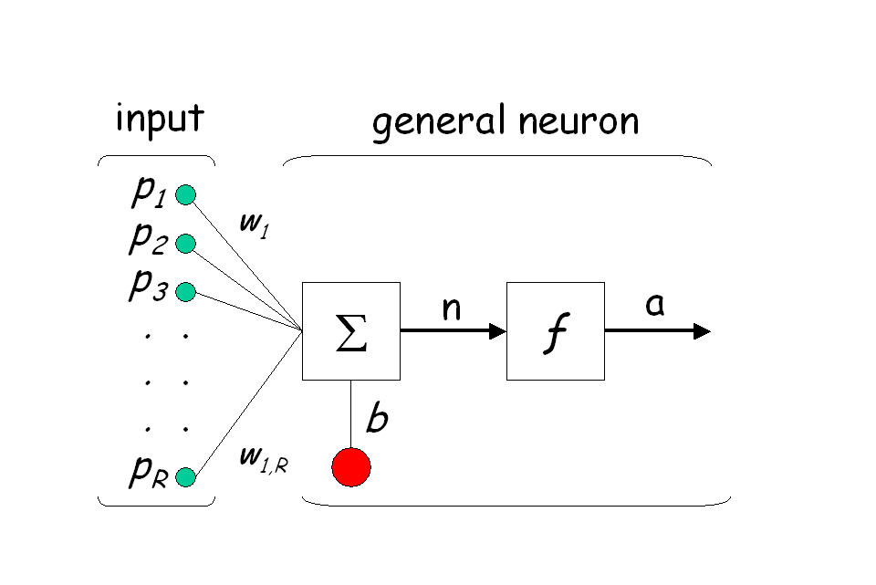
The ANN training has been performed in a Matlab environment, with two main stages: (1) learning rules - methods of deriving the changes (weights and biases) that might be used in a developing network, in order to move the network outputs closer to the target output and (2) training rules - a process in which a network is actually adjusted to perform a particular job (Rosenblatt, 1961). ANN has been designed as a multilayer feedforward perceptron, with high ability to generalize from backpropagation training vectors and learn from initially randomly distributed connections (Rosenblatt, 1961; Hagan at all, 1996; Looney, 1997). The backpropagation refers to the manner in which the gradient is computed for nonlinear multilayer networks (Hagen et al. 1996) (Fig. A-1).

Figure A-1. The architecture of one layer in a multilayer feedforward perceptron.

Where: p₁, p₂, .., p_{R} – input; w₁, w₂, .., w_{R} – weights; Σ- sum of the weighted inputs; b – bias; n – number of neurons; a – network output, ƒ- activation function; R – number of elements in input vector.

In the training process, the following three activation functions have been used: log-sigmoid, tag-sigmoid and linear transfer functions. The above-mentioned functions have been used alone or in combination (ex: log-sigmoid + linear transfer function). The training process has been conducted through two different ways: batch mode and batch gradient descend mode (Hagen et all, 1996). To protect ANN from overfitting during the training process, an early stopping method was used. All available data were divided into three subsets. The first data subset was used for the training, in which the ANN gradient was computed, and network weights and biases were updated. The second data subset was used in validation process. The training was stopped when error on validation begin to rise. The weights and biases at the minimum of validation error were applied. The third data set was used to test the validation process.

Further ANN training on IKONOS and Landsat TM5 images is required to develop closing algorithm(s) for Landsat fractional snow cover estimation (LandsatFSC). The following research step will take MODIS fractional snow cover estimation (ModisFSC), with LandsatFSC as a ground truth.

Validation of LandsatFSC and ModisFSC will be performed based on ground measurements collected in the instrumental watershed, operated by the Center for Snow and Avalanche Studies – the Senator Beck Basin Study Area in the Ouray Range District of the Uncompahgre National Forest in the western San Juan Mountains (Figs. A-2, A-3).

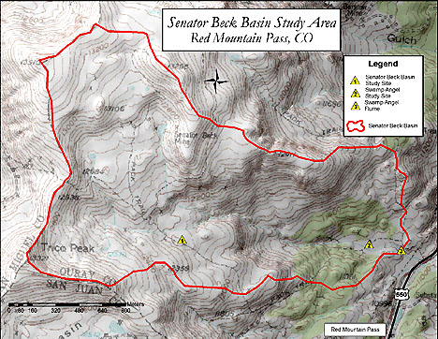
Figure A-2. Topographic map of the Senator Beck Study Area (http://www.snowstudies.org).

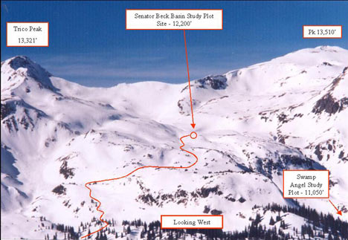

Figure A-3. Winter snow cover in the Senator Beck Study Area (http://www.snowstudies.org)

References:

Hagan, M.T., Demuth, H.B., Beale, M., 1996, Neural Network Design, PWS Publishing Company, p. 1 – 1960.

Lonney, C.G., 1997, Pattern recognition using neural network. Theory and Algorithms for engineers and scientists, Oxford University Press, p. 458.

Rosenblatt, F., 1961, Principles of neurodynamics. Perceptrons and the theory of brain

