LTRR-SRP II : The Current Drought In Context: A Tree-Ring Based Evaluation Of Water Supply Variability For The Salt-Verde River Basin
PROGRESS REPORT #1
4 November 2005

Katherine K. Hirschboeck & David M. Meko
Laboratory of Tree-Ring Research, The University of Arizona

WORK  PHASES | Month
WORK  PHASES | SRP Budget Year 1 |  |  |  |  |  |  |  |  |  | SRP Budget Year 2
WORK  PHASES | 2005 |  |  |  |  | 2006 |  |  |  |  |  |  |  |  |  |  |  |  | 2007
WORK  PHASES | A | S | O | N | D | J | F | M | A | M |  | J | J | A | S | O | N | D |  | J | F | M | A |  | M | J | J | A
1. Field collections
2. Processing & new chronologies
3.Re-calibration / update of reconstructions w/ climate analyses |  | Ongoing climatic analysis, building on LTRR-SRP I ➔
4. Snow study
5. Integration & final report

As of the first week of November 2005, progress has been made on Work Phases, (1), (2) and (4) in addition to the continuation of ongoing climatic analysis work that builds on LTRR-SRP I. (part of Work Phase 3).

WORK PHASE 1: Collection and recollection of tree ring cores from selected sites in order to develop new chronologies and update existing chronologies.

Five field trips have been taken so far. Typically these trips have taken 2-3 days, and have been in pairs, with the first trip for scouting the area and the follow-up trip for collecting samples. A total of 16 sites are listed in Table 1 and the general locations of the sites are shown in Figure 1. Not all of these will eventually be operationally usable. In particular, the sites labeled as "Exploratory" (E) in the "Type of Collection"column (T) of Table 1 are unlikely to result in chronologies for this project but may be useful in future work.

Sites labeled as suitable for "Chronology Building" (B) under column (T) of Table 1 are updates, with the exception of East Clear Creek, a very promising ponderosa pine site in a key location near the edge of the Mogollon Rim north of Payson.

The sampling strategy has been to collect two cores each from 20-30 trees at a site, with care to sample several young trees as well as the oldest-looking trees at the site. The young trees are needed for the earlywood-latewood portion of the study. This convention applies to Douglas Fir (PSME) and Ponderosa Pine (PIPO) species only. For Piñon Pine (PIED) the latewood is generally too thin and invariable to be useful for a separate chronology, and 7-10 trees suffice for updating an existing chronology.
Table 1. Field collections of tree-ring sites

-----------------------------------------------------------------------------
N Site Name Species¹ Lat Long El(ft) T² S³ Date⁴ N_{T}⁵
-----------------------------------------------------------------------------

1 Black River Fir PSME 33.81 -109.32 6754 B P 2005-09-23 16
2 Black Mountain Lookout PSME 33.38 -108.22 8692 B S 2005-10-13 15
3 Dry Creek PIED 34.89 -111.82 4526 B R 2005-10-21 0
4 East Clear Creek PIPO 34.55 -111.16 6921 B R 2005-11-03 0
5 Gus Pearson PIPO 35.27 -111.74 7396 B S 2005-10-27 0
6 Jacks Canyon PIED 34.74 -111.10 6314 B R 2005-11-02 0
7 Mogollon Rim West Fir PSME 34.44 -111.29 7511 B R 2005-11-03 0
8 Oak Spring Canyon PIPO 33.92 -111.40 6199 B R 2005-10-19 0
9 Robinson Mountain PIPO 35.38 -111.56 7306 B S 2005-10-27 0
10 Red Butte PIED 35.82 -112.07 6335 B S 2005-10-28 0
11 Rocky Gulch PIPO 34.73 -111.50 6494 B R 2005-11-02 0
12 Slate Mountain PIPO 35.52 -111.83 6954 B S 2005-10-28 0
13 Sitgreaves Gravel Pit PIPO 34.25 -109.94 6740 B P 2005-09-24 0
14 Wolf Head Draw Fir PSME 33.40 -108.22 6593 B P 2005-10-13 0
15 Oak Creek Canyon PSME 35.03 -111.74 5904 E P 2005-10-21 0
16 Wolf Creek Campground PIPO 34.45 -112.45 5871 E P 2005-10-21 0

-----------------------------------------------------------------------------
¹Species: PSME = Pseudotsuga menziesii (Douglas Fir); PIPO = Pinus ponderosa (Ponderosa Pine); PIED = Pinus edulis (Piñon Pine)
²T: Type of collection (B=chronology building, E=exploratory)
³S: Status (R=reconnaissance or spot-sampled, S=full samples collected,
P=prepared (mounted and sanded), D=dated, M=measured, C=chronology built
⁴N_{T}: number of trees samples

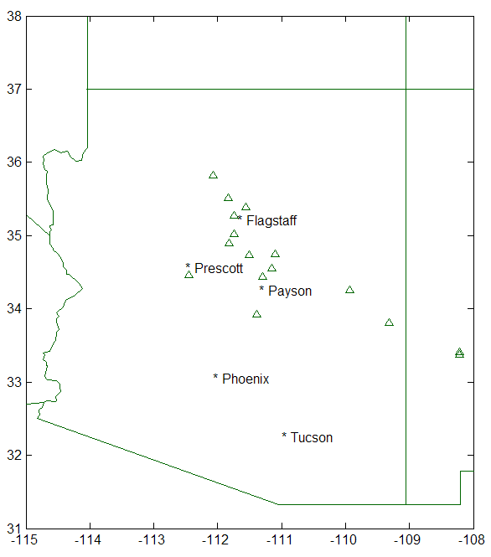

Figure 1. Locations of tree-ring sites collected or scouted as of November 4, 2005.

WORK PHASE 2: Processing of the new collections.

The "Status" (S) column in Table 1 indicates the status of each collection in the sample preparation and processing sequence. Several of the new collections are mounted and sanded and we are on schedule with this work phase.

WORK PHASE 3: Analysis of droughts and high flow extreme years in the context of present and past climatic variability.

Building on the results of LTRR-SRP I, analysis of correlation fields and composite maps of key periods of extreme episodes of high and low flow has continued. In addition, updated USGS flow records at the monthly, daily, and instantaneous peak scale have been obtained to examine hydroclimatic relationships over seasonal, monthly, weekly and daily time frames as needed.

WORK PHASE 4: Analysis of the relationship between tree-ring data and snow variables through remotely sensed observations.

A series of IKONOS, Landsat and MODIS archived images have been purchased; a collection of 10 m resolution USGS Seamless DEM datasets have been obtained; and meteorological and hydrological datasets for the western section of the study area selected for algorithm development (San Juan Mountains) have been collected. Initial processing and co-registration of the images has taken place.

SUMMARY

Thus far we are on schedule with our estimated project time line. The only setback has been a delay in getting the project budget set up within the University of Arizona Sponsored Projects office. We are still awaiting a project account #, but in the interim, the Laboratory of Tree-Ring Research has been covering our expenses until our account is established and we can reimburse the Lab.

