COURSE LEARNING PHILOSOPHY, GOALS, & PEDAGOGICAL BASIS

NATS 101 INTRODUCTION TO GLOBAL CHANGE

LEARNING PHILOSOPHY:

Statement to students about the learning philosophy underlying the nats 101 "introduction to global change" course:
This course is designed to help you learn the course material in ways that are different from traditional lecture courses. It is based on the following precepts:
• Class time is valuable and should be a time of active, hands-on, and engaged learning by students,
• Students learn best when they come to class prepared with sufficient background knowledge (from reading) to which new material can be added,
• Students learn best when they have achieved a common "starting place" from which to deepen their understanding of a concept,
• A group of people working together cooperatively can solve complex problems more easily and at a higher level than an individual working alone, and
• To achieve success in group activities, each individual has to be perceived as someone with something to offer, and each individual is responsible for preparing and contributing his or her own individual knowledge.
Inspired by the above, your learning in this class is designed to take place in different ways. You will do some class work individually, but you will work on other types of activities in an assigned “working group” or collaborative learning team in which the members help and support each other’s efforts to understand and work with the course material. Class time will generally consist of a variety of learning activities: e.g., mini-lectures, individual writing exercises, paired or small-group discussions, hands-on small-group problem solving, project work, individual and group tests, etc.

COURSE GOALS AS STATED TO STUDENTS IN ONLINE COURSE SYLLABUS:
Learning outcomes we hope students will achieve in this class:
- You will develop an appreciation for the complexity of the scientific endeavor, how it is evaluated by peers and how it is communicated to the public
- You will gain experience in using the tools of science: observation; data analysis, presentation, and interpretation; quantitative and symbolic representation of nature, including modeling; hypothesis testing and critical reasoning.
- You will gain facility in writing precisely and critically about scientific topics in both short, impromptu writing and more formal analytical writing.
- You will learn to work effectively in a "working group" environment.
- You will build on your understanding of key underlying physical science concepts (i.e., matter, electromagnetism, energy & thermodynamics, force & motion) and you will be able to articulate the role played by these physical concepts in specific global change processes.
- You will gain an understanding of the essential components of the Earth system (atmosphere, hydrosphere, biosphere, and geosphere) that are involved in global change processes and the feedbacks that link these components.
- You will be able to explain and discuss the scientific principles underlying global environmental change problems and issues, (e.g., climatic variability, global warming due to an enhanced greenhouse effect, ozone depletion, deforestation); and you will be able to critically evaluate the logic and evidence that underlie various theories about the nature of global change, especially global warming.
- You will develop a global awareness of how human beings affect -- and are affected by -- many of the processes linked to global environmental change
- You will be able to apply knowledge obtained in the course to make informed, scientifically based, decisions about personal role and responsibilities as a human being who influences -- and is influenced by -- a globally changing world.

PEDAGOGICAL BASIS & MODELS OF STUDENT LEARNING USED IN NATS 101

My NATS 101 Introduction to Global Change course has been structured loosely around the pedagogical model of:
Larry Michaelsen, L. Dee Fink, Robert H. Black (1996) What every faculty developer needs to know about learning groups in L. Richlin, ed. To Improve the Academy, Vol 15 (pp 31-57). Stillwater, OK: New Forums Press and the Professional and Organizational Development Network in Higher Education.

This model uses collaborative leaning groups and a Team Learning Instructional Activity Sequence which includes a Readiness Assurance Process. The process (illustrated at right) is used to introduce each major instructional unit and to ensure that students are intellectually prepared for assignments needing higher level cognitive skills. One result of the process is that "students encounter new data that test their understanding of key concepts at least five different times and in five very different ways." (Michaelsen et al., 1996)

My class of approximately 150 students is divided into 20 collaborative learning groups. Students work together in their assigned groups periodically throughout the semester to apply course concepts they have learned in their reading and my lecture presentations. Group activities include hands-on learning activities such as: analyzing time series graphs of geophysical phenomena, discussing the nature of the scientific process as represented in quotes from scientists and cartoons about science, conducting simple demonstrations and/or experiments, assuming a stakeholder role to debate the global warming issue, categorizing wood samples for applicability in tree-ring research, and participating in a tree-ring research project in which students plot data from "paper" tree-ring cores and crossdate their plots with others in their group to develop a chronology which can then be compared with the data and chronologies from other groups in a class-wide hypothesis-testing exercise. Most of these activities are facilitated by undergraduate preceptors and my graduate teaching assistants, who have been trained in the activities ahead of time. My preceptors are enrolled in the course while they serve as preceptors and are also enrolled in the University Teaching Teams Program UNVR preceptor course. I meet with them and my graduate teaching assistants one hour every week at our "Teaching Team" meeting to discuss the course and prepare them for upcoming activities. In addition I meet separately with my graduate teaching assistants for an hour twice a week to discuss the course and prepare learning activities and materials for upcoming classes. Together we work as a true "teaching team" in the spirit of the University Teaching Team Program.

In my adaptation of the Michaelson et al. (1996) collaborative learning model, I have focused on the pivotal role of feedback in developing students’ higher-level cognitive skills and have integrated several different types of teaching technology into Michaelson's Team Learning Instructional Activity Sequence to assist in this feedback. The following figure illustrates my adaptations, and the explanation following provides some details of the various steps in the sequence:

K.K. Hirschboeck's Technology-Based Adaptation of Michaelson et al.'s (1966)
Team Learning Instructional Activity Sequence as Implemented
in NATS 101, Introduction to Global Change
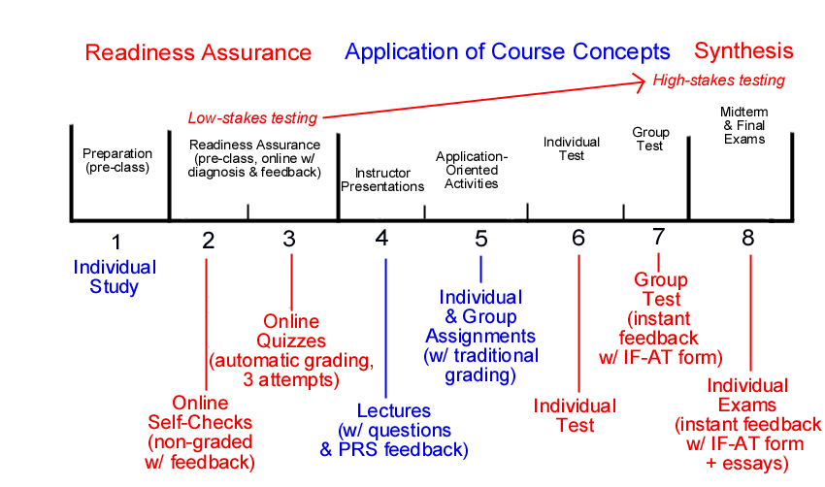

Steps 1, 2, & 3:

I conduct the Readiness Assurance Process prior to class via online WebCT Self Tests and Quizzes. The Self Tests (Step 2) (called "Self Checks" in my NATS 101 course) are not graded and are based on the textbook reading material (Step 1). For each Self Check question I have prepared written feedback comments for all correct and incorrect answers, referring the student back to pages or figures in the text to correct a misunderstanding revealed by the selection of an incorrect answer. The online Quizzes (Step 3) are also based on the reading material, but the questions are a bit more difficult than the Self Check questions. Students may take the WebCT online quiz three times and they receive a grade based on the average of all three attempts. Their quiz is graded instantly within WebCT, but when the students view their quiz results, they are shown only which questions they got wrong, and not what the correct answer is. They must figure out what the right answer is on their own and re-take the test one or two more times to improve their grade.

Step 4:

During class presentations (Step 4) I engage the students in actively thinking about the lecture material by posing questions and receiving the students' response to the questions immediately via the Integrated Learning Center's Personal Responder System (PRS). This system is based on remote control devices that allow individual students to send their answers to a receiving unit linked to a classroom computer which then displays the entire class's results for a particular multiple choice question. Once displayed, I can discuss the answers with the students, determine whether the material just presented has been properly comprehended, and correct misunderstandings.
Steps 5, 6, & 7:

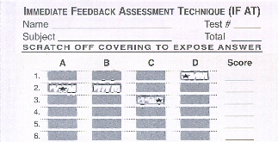
After we have completed a set of related topics in class, including application oriented individual and group class activities and homework assignments (Step 5) the students are tested on that segment of the material with an Individual Test (Step 6) that is followed immediately by the students taking the same test together as a Group Test in their collaborative learning groups (Step 7). Students discuss and debate each question in their groups, leaning from each other and correcting misunderstandings in the process. To facilitate immediate grading of the Group Tests, I use a specially designed testing tool that provides instant feedback to students on their answers and allows them to determine what the correct answer is for a given question before moving on to the next question. The tool -- a scratch-off answer form that reveals the correct answer with a "star" once a student selects it -- is called the Immediate Feedback Assessment Technique (IF-AT). It was developed by Michael Epstein, Ph.D., of Rider University, NJ and is described fully at: http://www.epsteineducation.com/ The IF-AT form has been one of the most successful teaching innovations I have introduced to the course. An anonymous survey which evaluates the form was completed by students in my Fall 2000 NATS class and can be found at: http://fpcluster.ccit.arizona.edu/khirschboeck/if-at.htm

Step 8:

Finally, at the mid-point and end of the semester, students are tested on their overall comprehension of the course material and their ability to apply and synthesize the concepts in a high-stakes Midterm Exam and Final Exam (Step 8). In the exams, the students use the IF-AT form again, this time as individuals.

The above modifications of the Michaelsen et al. (1996) instructional activity sequence have allowed me to structure the course using a "Multi-Tiered Testing-and-Feedback Approach" that tests student's knowledge and provides immediate feedback in a series of testing situations from low-stakes, non-graded self checks to high-stakes individual exams which test students' overall comprehension and ability to synthesize several aspects of the course material . The multi-tiered approach allows the student to gain knowledge and confidence with the material at each progressive level because of the immediate feedback provided.

