La Ventana

Discussion
The dendroarchaeology of La Ventana Mesa is interesting and informative on several levels. When combined with archaeological data and historical documents, a richer and more elaborate understanding of the human occupation of the mesa will be attained. Such a synthesis will be the subject of a future report to the BLM-Rio Puerco Field Office. This summary includes only the archaeological tree-ring data.

In total, we collected 189 tree-ring samples from 12 sites and one isolated feature. Four of the sites are Euroamerican homesteads, eight sites are Early Navajo constructs, and the isolate feature dates to the early 20th century. Of the 187 samples (two were lost between La Ventana Mesa and Tucson), 102 (54.5%) yielded dates, including 16 cutting or near cutting dates.; these proportions are significantly higher than the long-term LTRR average of 35 percent dating success. The earliest cutting/near cutting date is 1767+B and the latest date is 1959+v.
In terms of species, we collected 89 pinyons, 70 junipers, 25 ponderosas, and 4 oaks. These proportions reflect species availability in the environment, the choices of the builders, and to a much lesser degree, our sampling strategies. The dating success rate of the different species (see below is also informative:
Pinyon = 89 samples, 74 dates (83%)
Ponderosa = 25 samples, 21 dates (84%)
Juniper = 70 samples, 10 dates (10%)
Oak = 4 samples, 0 dates (0%)

Obviously, oak rarely (if ever) dates in this area, juniper dates on occasion, and pinyon and juniper date most of the time. These proportions, however, reflect the cultural wood use practices of the various groups who used La Ventana Mesa in the past.

Navajo sites

The eight Early Navajo sites yielded 84 samples and 29 dates—a 34.5 percent dating success ratio that is equivalent to the long-term LTRR rate. Of the 29 dates, however, only four are cutting of near cutting dates. The earliest near cutting date is 1767+B and the latest date is 1805vv. Clearly, the Early Navajo occupation was a mid- to late-19th century phenomenon.

In terms of species, juniper (n=50) and pinyon (n=34) were the preferred building materials of the Early Navajo. Unfortunately, only two percent (n=1) of the Early Navajo juniper samples dated. In contrast, 28 of the 34 pinyon samples (82%) dated. This discrepancy is related to Early Navajo wood use practices and is discussed below.

Sample context appears to have had little effect on dating Early Navajo samples. Fifteen (15) juniper samples were collected from architectural contexts (hogans), but only one dated (BBM-35; 1743vv); 35 samples were collected from CMTs, most as cross sections, and none yielded dates. In contrast, pinyon samples from Early Navajo architectural contexts (n=10) yielded six dates and pinyon CMT samples (n=24) yielded 21 dates (87.5%). Obviously the pinyon samples have a higher dating success rate, but the discrepancy is more a result of cultural choices than species use. Hogans, as relatively circular single-room structures require four main support beams (forks) and dozens of side beams (leaners). Other than the forks, which determine the height of the structures, beams need not be of any particular size o shape. Therefore, the Early Navajo builders could have chosen small irregular-shaped beams or branches. The junipers that grow on the mesa are predominately either Juniperus osteosperma or Juniperus monosperma; the latter tends toward a more bushy growth form which often doesn’t crossdate, even among branches of the same tree. The Navajo selection of these trees directly impacted the dating success rate.

Historic Period Sites

The four historic period sites---the Reynolds Homestead, the Jones Homestead, the Maestas Homestead and The Fence—yielded 103 samples and 72 dates (69.9%), including 10 cutting or near cutting dates. The earliest near cutting date is 1919v comp (BBM-192) and the latest date is 1959+v (BBM-187). The historic period occupation appears to have been a predominately 1920s occupation, with some use in the 1930s; The Fence may have been used throughout the 1940s and 1950s, but the homesteads appear to have been abandoned by WWII.

In terms of species, historic period people used a wider variety of species than the Early Navajo, but in specific contexts. Pinyon (n=55) was used most widely, followed by ponderosa (n=25), juniper (n=19, and oak (n=4). Interestingly, ponderosa was used almost exclusively at the Reynolds Homestead (n=23), although two samples were collected from roof primary beams at the Maestas Homestead. Although the species distribution from the Fence was skewed by our sampling strategy (more junipers are part of the structure), no ponderosas or oaks were identified, nor do they grow in the vicinity.

The historic period samples, however, appear to represent the behaviors of different ethnic groups with different wood use practices. The graph below shows the species preferences of the Early Navajo and individual historic period sites. The Fence and Early Navajo data are most similar, but the dates and influence of our sampling strategy show that The Fence is not a Navajo feature. The Reynolds Homestead exhibits the most distinct wood use; the predominance of

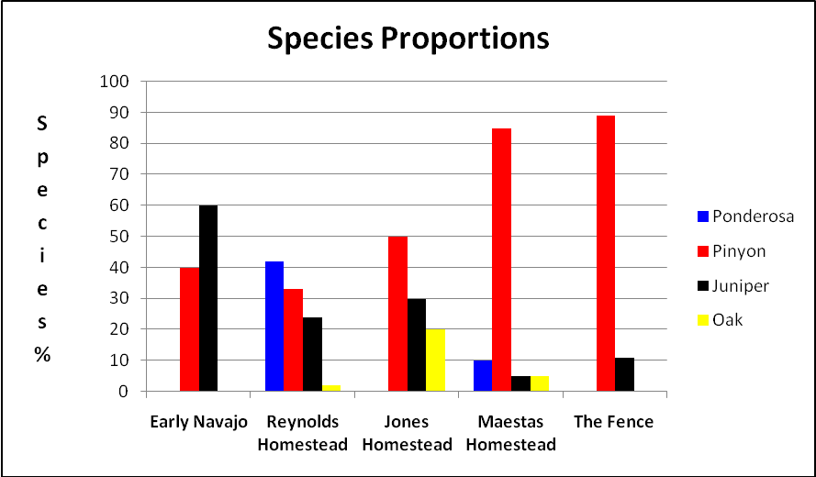

ponderosa, mostly as horizontal wall elements in the Main Cabin, is unique in the project area.

Based on the masonry architecture—as opposed to log-cabin construction—and species use, we suggest that , despite its name, the Jones Homestead was built by Hispanic, not Anglo occupants of the meas. It more closely resembles the wood use exhibited in the Maestas Homestead. Detailed historical research may help address this issue.

Conclusions

This exploration of dendroarchaeology on La Ventana Mesa has delineated portions of the Early Navajo occupation of the area and aspects of the early 20th century Euroamerican homesteading period. Dendroarchaeology is clearly a viable avenue for exploring different occupations, but more research is needed in order to fully understand past land use. In the Navajo case, more detailed ceramic and lithic analyses of surface assemblages will be a major contribution, unless excavations are conducted. In the Euroamerican case. More historic documents research, oral history research, and archaeological documentation will help illuminate the early 20th century land use patterns. Given the potential for increased site visitation with the opening of the Continental Divide Trail, such research could contribute to both preservation of the sites and public education/outreach so trail users could more fully appreciate their journey across this unique landscape.

