

Department of Botany, 3165
Aven Nelson Building
1000 E. University Avenue
Laramie, Wyoming 82071
(307) 766-2380 fax: (307) 766-2851

March 22, 2010

Connie Woodhouse
Environmental Initiative Search Committee
Laboratory of Tree-Ring Research
College of Science
University of Arizona
P.O. Box 210058
Tucson, Arizona 85721-0058

Dear Dr. Woodhouse:

I am writing in support of John Bradford’s application for your Environmental Initiative. I have worked with John for the past 9 years and I was John’s advisor for his doctoral work. I have had a variety of experiences with John both during and after his doctoral program. We have written a number of papers together some of which were directly related to his doctoral research and others not. I have enjoyed all of my interactions with John. He is intelligent with great quantitative skills, a careful thinker, an excellent writer, and a hard worker.
The theme of John’s doctoral research was the effects of land use on ecosystems. His work in the central US involved evaluating the effect of the conversion of grassland to cropland on aboveground net primary production (ANPP). This work entailed the analysis of crop statistical data as well as remotely sensed data for ANPP. The outcomes of these analyses were in one published manuscript in Ecology , one in Remote Sensing of Environment, and another in Ecosystems. The second part of his research involved the conversion of native perennial grassland-shrubland in the intermountain zone to annual grasslands via the invasion by Bromus tectorum. This work also required the analysis of remotely sensed data as well as field data collection and simulation modeling. The outcome of this research was a published paper in the Journal of Vegetation Science. One of the key points of this overview of John’s doctoral research is to emphasize the breadth of his skills. John is fearless in tackling new challenges and has dealt with simulation models with the same effectiveness as he applied to the analysis of crop production statistics from all of the counties in the Great Plains.
Since he completed his doctoral program John and I have continued to collaborate. We have a published paper in Ecosystems using a simulation model to investigate the ecohydrology of the shortgrass steppe and we have conducted a large-scale analysis of the arid and semiarid portions of the Great Plains and intermountain West evaluating the size class distribution of precipitation events and the distribution of the lengths of intervals between events. This precipitation regime work has resulted in two invited presentations at the annual meeting of the Ecological Society of America, both of which John presented, a paper published in Ecohydrology, and another manuscript in preparation also to be submitted to Ecohydrology. As in all of my other interactions with John, I have thoroughly enjoyed our recent work together.
While John’s recent research and publications have focused on forest ecosystems in the Great Lakes region, I know from my interactions with him that he is eager to return to working in ecosystems in the West. John and I currently share a postdoc who works in my lab in the Botany Department. His research is focused on understanding the effects of climate change on the lower tree line in the sagebrush steppe. Currently this work is entirely simulation based, but we wrote a NSF proposal that was submitted in January 2010 to extend this work to field sites in the Medicine Bow Mountains of Wyoming. Our questions in this work all relate to the interactive effects of the mountain pine beetle epidemic and climate change on the structure of lower tree line plant communities.
In addition to his other qualities, John is gregarious and a pleasure to be around. He interacts well with groups and is generous with his time. He is an excellent team player. He has an engaging speaking style and all of his seminars and talks at national meeting that I have heard have been outstanding.
I know that John would be an outstanding addition to the University of Arizona faculty and I enthusiastically recommend him to you.

Sincerely yours,
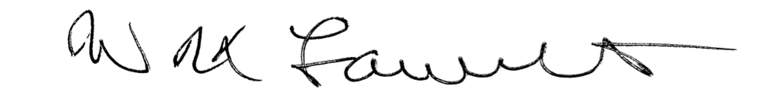

W. K. Lauenroth,
Professor

